FAMEDD
PROJECT-I REPORT

Submitted by

Mohammad Hurmaan Siddiqui

Enrollment No. :2021-310-152

in partial fulfillment for the award of the degree of

BACHELOR OF COMPUTER APPLICATION

Under the supervision of
MR. SYED ALI MEHDI

Department of Computer Science & Engineering
School of Engineering Sciences & Technology

JAMIA HAMDARD
(Deemed to be University)

New Delhi-110062
2024

DECLARATION

I, Mr. Mohammad Hurmaan Siddiqui a student BACHELOR OF TECHNOLOGY (BTech) (Enrolment No: 2021-310-152) hereby declare that the dissertation entitled “FAMEDD” which is being submitted by me to the Department of Computer Science & Engineering, School of Engineering Sciences & Technology, Jamia Hamdard, New Delhi in partial fulfillment of the requirement for the award of the degree of BACHELOR OF TECHNOLOGY (BTech), is my original work and has not been submitted anywhere else for the award of any Degree, Diploma, Associateship, Fellowship or other similar title or recognition.

(Signature and Name of the Applicant)
Date:
Place:

ACKNOWLEDGMENT
I take this opportunity to express my gratitude to my Project Supervisor, MR. Syed Ali Mehdi for this unwavering encouragement and support throughout this project. His insight and expertise in this motivated and supported me during this project. It is my privilege and honor to have worked under his supervision. His valuable guidance and helpful discussion in every stage of this project really helped me in materializing this project. Without his constructive direction and valuable advice, this would not have been completed. Their valuable insights and suggestions have helped me to develop a deeper understanding of Machine learning and its applications. I would like to thank Jamia Hamdard New Delhi, for providing me with the resources and facilities required for the successful completion of this project. My gratitude is also extended to all teaching and non-teaching staff for their unwavering encouragement and support my pursuit for academics.

Mohd Hurmaan Siddiqui
2021 - 310 – 152
Computer Science and Technology
6th Semester

CONTENTS
SERIAL NO. | TOPICS | PAGE NO.
1. | Abstract | 1
2. | Introduction | 2-3
3. | Problem Statement | 4-6
4. | Proposed Work | 7-8
5. | System Design | 9-12
6. | Implementation | 13-18
7. | Result Analysis | 19-31
8. | Future Enhancement and Scope | 32
9. | Conclusion | 33
10. | Bibliography | 34

ABSTRACT

Famedd is a user-friendly, website-building platform. Our intuitive technology gives our users the freedom to design professional websites with ease that look amazing on any device.
Famedd is more than a website, though. We offer a complete set of tools to build your online presence, from getting found on search engines to building your business.
The idea of this project came to us when we were working on another project. An acquaintance of ours asked us to make a website for his business which was basically a car shop, or you can say a dealership of cars for which he was willing to give us a certain amount of money, since he knew that we were in 3rd year of our diploma and have a knowledge of web development. we agreed to make that project for him since we were getting good profit margin and making a project like that would be good with regards to our studies.
while we were creating the project and had created the UI, we showed the UI to some people and we saw more people being interested in having their own website and were willing to give us money to make their website for them so, we thought while we are making websites for other why don't we make a website for ourselves which will help us in reaching out to more people and have our own business and with that thought FAMEDD was born
In This project is aimed at developing a website that, if you want a website for yourself or for your business will help you get in touch with us, choose what kind of website you want and various features that you might like to have in your website. In today's world it has become necessary for small businesses to take themselves online have their and have their websit

INTRODUCTION

This project is aimed at developing a website that, if you want a website for yourself or for your business will help you get in touch with us, choose what kind of website you want and various features that you might like to have in your website. In today's world it has become necessary for small businesses to take themselves online have their and have their websites.

After the COVID-19 everyone now prefers to shop online, from groceries to clothes to food everything is now available for you to order online since every large brand or even a smaller one have their own websites from where you can shop but a small businessman or shop owner don't have the kind of money that these big businesses have to spend on a website.

So, for those people we have created this project called FAMEDD that will help you get a website which will look as good as the websites of big-name brands and would be affordable by you, we will create your UI for you will provide you with all necessary solutions.

Objective
Creating the It Provides a Interface to user to build their business live with the help of Websites. In our Regular life we see that more people are taking their business live with help of websites and FAMEDD.com can make the websites in the best price.

Scope
This project is aimed at developing a website that, if you want a website for yourself or for your business will help you get in touch with us, choose what kind of website you want and various features that you might like to have in your website. In today's world it has become necessary for small businesses to take themselves online have their and have their websites. After the COVID-19 everyone now prefers to shop online, from groceries to clothes to food everything is now available for you to order online since every large brand or even a smaller one have their own websites from where you can shop but a small businessman.

Background To Study
Google AdSense There are many ways to monetize your website traffic, and most of them are related to advertising third-party products or services to your website visitors. There are many advertising programs that can help you earn money nowadays, but the most popular is Google AdSense.
This advertising program was launched in mid2003 by Google and is currently the most popular advertising program on the Internet. It provides a good opportunity for webmasters and site owners to monetize their traffic — every year, Google pays over $10 billion to its publishers.
VoIP Virtually every company does at least some of its business online nowadays, and if yours is among them, then you need a communications solution made for the digital age. The best way to streamline your communications is with a voice over intern.

PROBLEM STATEMENT

The problem Background: The hospitality industry has witnessed a shift towards digital solutions for ordering and payments. Despite advancements, businesses face challenges in providing seamless and efficient services to customers. Problem Statement: Traditional ordering and payment systems in the hospitality industry are becoming obsolete, leading to inefficiencies and customer dissatisfaction. Businesses struggle with the integration of modern technologies into their operations, hindering the adoption of digital solutions.
Objectives: Evaluate the effectiveness of Famedd in addressing challenges related to digital ordering and payment systems. Assess the impact of Famedd on the efficiency and customer satisfaction of businesses in the hospitality sector. Research Questions: How does Famedd streamline the digital ordering process in comparison to traditional methods,

What challenges do businesses face in adopting and implementing Famedd and how can these challenges be mitigated? What is the impact of Famedd on customer satisfaction overall operational efficiency in the hospitality industry? Scope of the Study: The study focuses on the implementation and impact of Famedd in the hospitality sector.
Specific attention will be given to the integration process, user experience, and the overall effectiveness of Famedd in diverse business settings. Significance of the Study: This research aims to contribute valuable insights into the challenges and benefits of adopting digital ordering and payment systems using Famedd

The findings will provide practical recommendations for businesses looking to enhance their operations through technology adoption. Methodology: Utilize a mixed-methods approach, incorporating surveys, interviews, and case studies to gather both quantitative and qualitative data. Analyze data from businesses that have implemented Famedd and those that have not to draw comparisons.

Expected Outcomes: Identification of key success factors and challenges associated with Famedd implementation. Recommendations for businesses in the hospitality sector on maximizing the benefits of digital ordering and payment systems. Limitations: The study may be limited by the availability of businesses willing to participate. External factors such as regional regulations may impact the generalizability of findings. Conclusion: Summarize the importance of addressing challenges in digital ordering and payments within the hospitality industry. Emphasize the potential contribution of Famedd in overcoming these challenges. This problem formulation provides a framework for investigating the impact of Fammed in the hospitality industry. It can be adapted based on specific research goals, industry trends, and the evolving landscape of digital solutions in the restaurant and hospitality sector.

Objectives

User-Centric Design: Implement user-centric design principles within the constraints of HTML, CSS, and JS to ensure an intuitive and engaging user experience.
Content Presentation: Utilize HTML for structured content and CSS for styling to present relevant and captivating information about the destination, including tourist attractions and accommodations.
Technical Implementation: Demonstrate proficiency in using HTML, CSS, and JS for the development of a static webpage, ensuring effective integration of these technologies for a visually appealing and interactive interface.

Responsive Design: Apply CSS media queries to achieve responsive design, ensuring the webpage's compatibility and optimal display across various devices and screen sizes.
Interactivity with JavaScript: Integrate JavaScript functionalities, such as image sliders, interactive maps, or personalized recommendations, to enhance the webpage's interactivity and user engagement.
SEO Best Practices: Implement basic SEO practices within the HTML structure to optimize the webpage for search engines, enhancing visibility for potential tourists.
Performance Optimization: Utilize techniques like image compression and efficient script loading using HTML, CSS, and JS to optimize the webpage's performance, ensuring fast loading times.

Cross-Browser Compatibility: Test and address cross-browser compatibility issues, ensuring consistent functionality and appearance across various web browsers using HTML, CSS, and JS.
User Testing and Feedback: Conduct user testing to gather feedback on the usability and effectiveness of the webpage, incorporating insights to refine the design and functionality using HTML, CSS, and JS.
Documentation and Reflection: Provide detailed documentation of the design and development process, reflecting on challenges faced and lessons learned during the creation of the tourist landing webpage using only HTML, CSS, and JS.

These objectives align specifically with the use of HTML, CSS, and JS, emphasizing a comprehensive approach to design, development, and optimization within the chosen technological constraints.

PROPOSED WORK

The lab report outlines a proposed minor project involving the development of a Famedd webpage using HTML, CSS, and JavaScript. The objective is to create a visually appealing and interactive website, integrating key front-end technologies. The project will emphasize designing an engaging user interface with aesthetic elements and incorporating dynamic features through JavaScript. Navigation and user experience will be prioritized to ensure seamless exploration. By focusing on practical application, this initiative aims to enhance students' proficiency in web development.

Proposed Methodology/Algorithm

The proposed methodology for the lab report delineates a comprehensive strategy for developing the Famedd webpage, integrating HTML, CSS, and JavaScript. Commencing with HTML, the algorithm will systematically structure the webpage, defining essential elements, and establishing the overall layout. CSS will be deployed for styling, focusing on creating an aesthetically pleasing and responsive design that aligns with modern web standards.

The algorithm will then be delved into JavaScript implementation to introduce interactive elements and dynamic functionality, enhancing the overall user experience. This involves scripting actions such as image sliders, navigation menus, and form validations. The methodology prioritizes a user-centric approach, ensuring seamless navigation and optimal performance across devices.

Testing and debugging constitute integral components of the algorithm, ensuring the robustness and functionality of the webpage. Continuous refinement based on feedback and iterative testing will be implemented to address potential issues. Accessibility considerations will be woven into the algorithm to guarantee an inclusive experience for diverse users.

In summary, the proposed methodology emphasizes a systematic progression from HTML structure to CSS styling and culminating in JavaScript interactivity. This approach aims to produce a polished and functional tourist landing webpage, adhering to best practices in web development and user experience design.

Description of each step

Project Scope and Requirements Analysis:
Begin by outlining the objectives and requirements of the tourist landing webpage. Identify the target audience, key features, and overall goals to guide the development process.

HTML Structure:
Create the foundational structure of the webpage using HTML. Define essential elements such as headers, navigation menus, content sections, and footers. Ensure semantic and well-organized markup for accessibility and SEO.

CSS Styling:
Implement Cascading Style Sheets (CSS) to style the HTML elements. Focus on creating a visually appealing and responsive design. Apply styles for layout, typography, color schemes, and other aesthetic elements. Ensure compatibility across various devices and screen sizes.

JavaScript Integration:
Incorporate JavaScript to add interactivity and dynamic functionality. Implement features such as image sliders, interactive maps, or form validations to enhance user engagement. Ensure a seamless user experience by optimizing the performance of JavaScript code.

User Interface Enhancement:
Pay attention to the overall user interface design. Refine the layout, spacing, and visual elements for an intuitive and user-friendly experience. Prioritize responsiveness to ensure the webpage functions well on different devices.

Testing and Debugging:
Conduct rigorous testing at each development stage. Identify and address any bugs, usability issues, or performance concerns. Test across multiple browsers and devices to guarantee a consistent experience.

SYSTEM DESIGN

Functional Specification of System

User Interface (UI):
Homepage: A visually appealing and informative landing page displaying key attractions, images, and a concise overview of the destination using HTML and CSS.
Navigation: Intuitive navigation menu with links to different sections (About, Attractions, Accommodations) for seamless user experience, implemented with HTML and CSS.

Responsive Design:
CSS Media Queries: Implementation of CSS media queries to ensure the webpage's responsiveness across various devices, enhancing the user experience.

User Interaction:
Clickable Elements: Implementation of clickable elements like buttons and links, enhancing user interaction using HTML and CSS.
Forms: Utilization of HTML forms for user feedback and inquiries, enhancing user engagement and interaction.

JavaScript Interactivity:
Image Sliders: Integration of JavaScript-based image sliders showcasing destination highlights.
Interactive Maps: Implementation of interactive maps using JavaScript for an engaging exploration experience.

Documentation and Reflection:
Technical Documentation: Thorough documentation of HTML, CSS, and JS code, facilitating understanding and future modifications.
Reflection: A section in the report reflecting on the design decisions, challenges, and lessons learned during the development process. This functional specification outlines the specific features, technologies, and interactions that will be implemented in the tourist landing webpage system. It serves as a detailed guide for the development process, ensuring clarity and alignment with the project goal.

Designing a website involves a systematic workflow to ensure a cohesive, user-friendly, and visually appealing result. Below is a general outline of the website design workflow: Define Goals and Objectives: Clearly understand the purpose of the website. Identify the target audience and key goals the website should achieve Conduct Research: Analyze competitors and industry trends Gather information about the target audience and their preferences. Create a Sitemap: Outline the structure and hierarchy of the website's pages. Define the navigation and user flow Wireframing: Develop wireframes that represent the basic structure and layout of each page. Focus on placement of elements, functionality, and user experience without detailing design elements. Design Mockups: Create high-fidelity design mockups using graphic design tools. Incorporate branding elements, colors, typography, and images. Ensure the design aligns with the overall goals of the website.

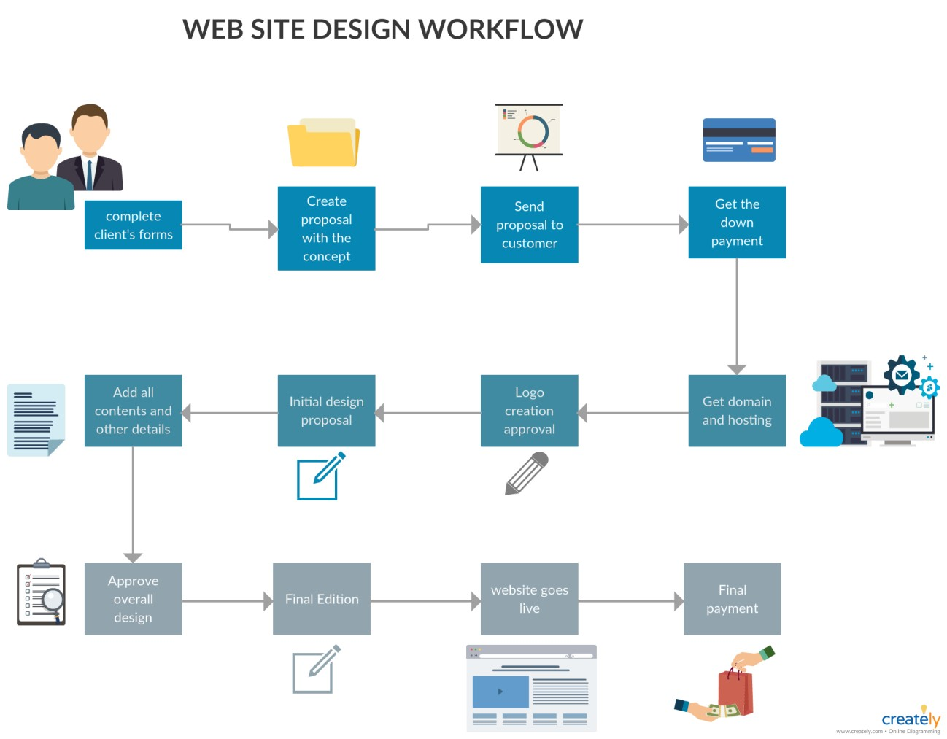

Figure 1: Detailed Flowchart of the Webpage

An Entity-Relationship (ER) diagram is a visual representation of the data model that shows the relationships among entities in a database. It is a fundamental component of database design and provides a clear and concise way to represent the structure of a database. Here's an explanation of key components and concepts within an ER diagram: Entities: Entities represent objects or concepts in the real world that are distinguishable from each other. In an ER diagram, entities are typically depicted as rectangles with the entity name inside. Attributes: Attributes are properties or characteristics of entities. They are shown as ovals connected to their respective entities by lines. For example, if "Person" is an entity, it may have attributes such as "Name," "Address," and "Date of Birth. “Relationships: Relationships illustrate how entities are related to each other. Relationships are depicted as diamond shapes connected by lines to the related entities. Cardinality notations (such as 1:1, 1: N, N:M) indicate the number of instances of one entity related to another.
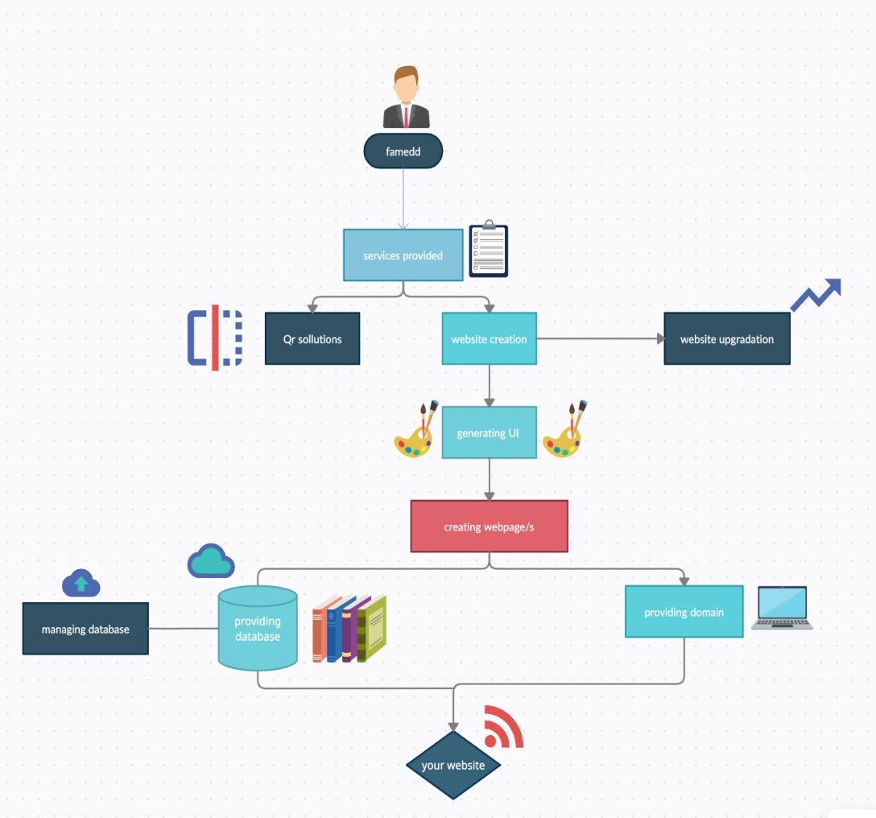

Figure 2: Detailed ER-Diagram of the Webpage

A Data Flow Diagram (DFD) is a graphical representation of the flow of data within a system. It is commonly used in system analysis and design to visualize how data moves through a system and how processes transform input data into output data. Here's an explanation of the key components and symbols used in a DFD: Processes: Processes represent activities or transformations that occur within the system. They are depicted as circles or ovals. Each process takes input data, performs a specific function, and produces output data. Data Flows: Data flows represent the movement of data between processes, data stores, and external entities. They are represented by arrows and indicate the direction of data flow. Data flows can be labeled to specify the type of data being transferred. Data Stores: Data stores represent repositories where data is stored. They are typically depicted as rectangles. Data stores can represent databases, files, or any other storage system. External Entities: External entities represent sources or destinations of data outside the system being modeled. They are represented as squares or rectangles. External entities interact with the system by providing input or receiving output.
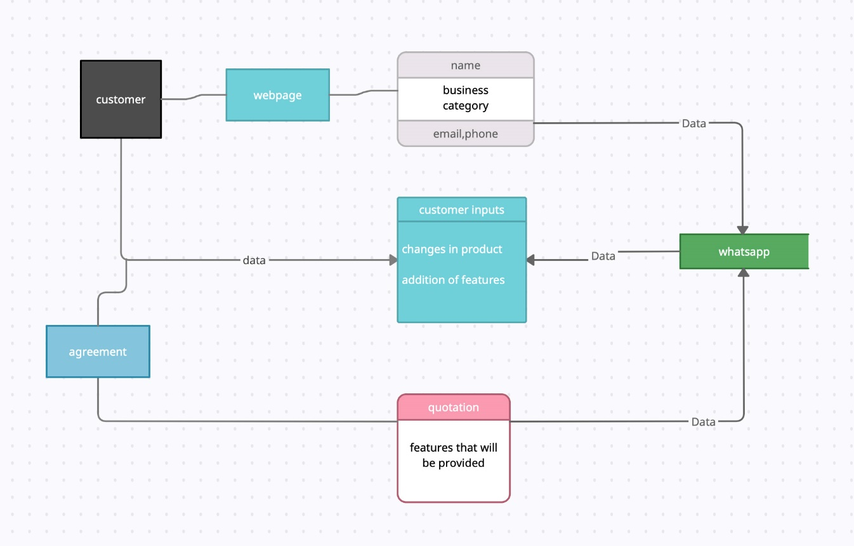

Figure 3: Detailed DFD Diagram of the Webpage

IMPLEMENTATION

The webpage is crafted with HTML for content structure, CSS for aesthetic styling, and JavaScript for dynamic functionality. HTML defines the page's elements, CSS styles them for a visually pleasing layout, and JavaScript adds interactivity, making the webpage responsive. This combination ensures a seamless user experience, allowing visitors to engage with content, navigate efficiently, and enjoy an aesthetically pleasing presentation on the static webpage.

Crafting Structure Of the webpage using HTML
Creating the structure of a web page using HTML is a foundational step in web development. HTML, or Hyper Text Markup Language, provides the essential structure that browsers use to render content. The process begins with the declaration of the document type and the opening and closing HTML tags. Within the HTML document, the <head> section contains metadata, such as the title and links to external stylesheets, while the <body> section encapsulates the visible content.
Tags like <header>, <nav>, <main>, and <footer> help delineate different sections of the page, aiding in semantic structuring. Heading tags (<h1> to <h6>) establish hierarchy, and paragraph tags (<p>) organize text content. Lists, both ordered (<ol>) and unordered (<ul>), assist in presenting information distinctly.
Div (<div>) and spans (<span>) are versatile containers for grouping and styling elements. Form elements, including <form>, <input>, and <button>, facilitate user interaction. Anchors (<a>) link to other pages or external resources.
Semantic tags like <article>, <section>, and <aside> add meaning to content, aiding accessibility and search engine optimization. Multimedia elements like <img> and
<video> enrich the visual experience, while tables (<table>), if needed, organize data logically.
HTML attributes, such as class and id, enhance styling and scripting. Comments <! -- -
-> allow developers to annotate code for clarity. Proper indentation and whitespace contribute to code readability.
In summary, creating the structure of a web page with HTML involves a thoughtful use of tags, attributes, and semantic elements to organize content logically and create a foundation for further styling and interactivity.
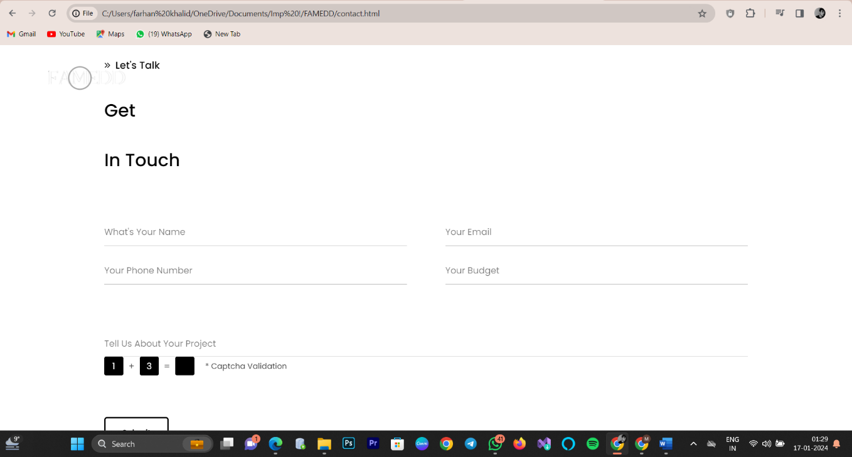

Figure 4: Picture to show the small initial part of the Webpage using html

(Picture Ref.: Screenshot from WebPage)

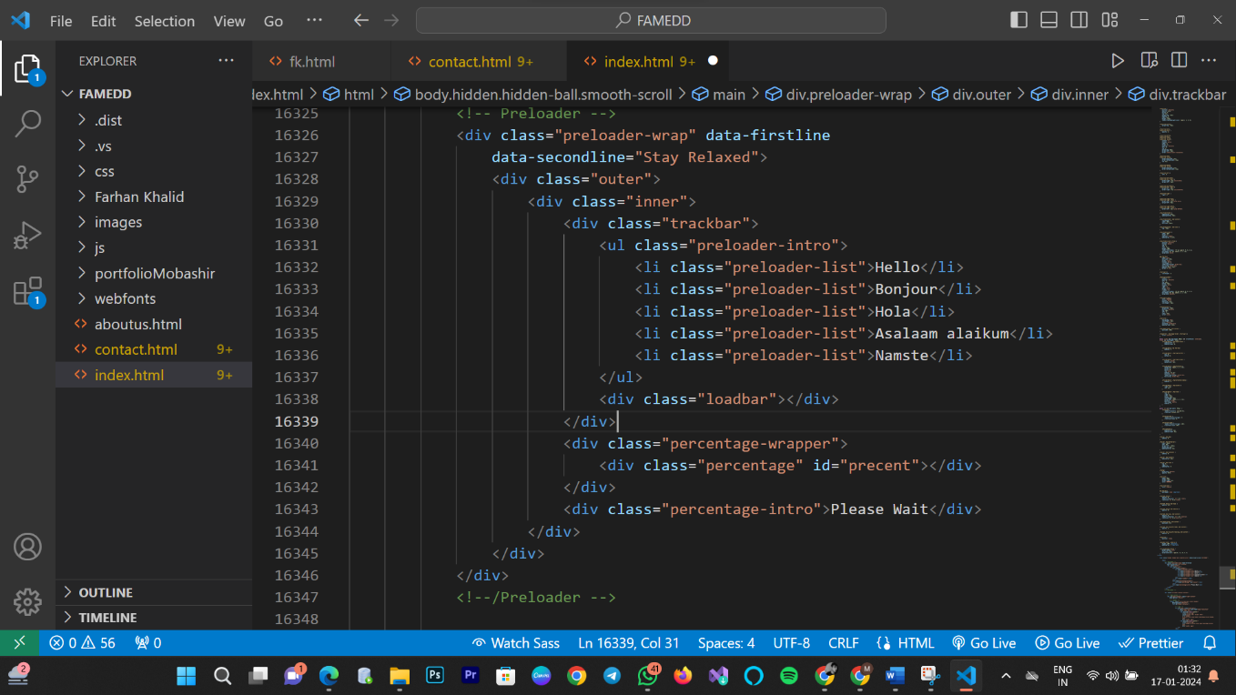

Figure 5: Picture to show some part of source code (HTML)

(Picture Ref.: Screenshot from WebPage)

Styling to the web page using CSS
Adding styling to a web page using CSS is a pivotal step in enhancing its visual appeal and user experience. Cascading Style Sheets (CSS) allows developers to control the presentation and layout of HTML elements. Selectors, declarations, and properties are the core components of CSS.
Selectors target HTML elements, classes, or IDs, enabling precise styling application. Declarations consist of property-value pairs, defining the desired appearance. Properties dictate aspects like color, font, margin, padding, and more. CSS rules are often stored in external style sheets or embedded directly within the HTML document.
Selectors can be broad, applying styles to entire document elements, or specific, targeting individual elements with unique IDs or classes. This flexibility allows for a cohesive design across multiple pages or tailored styling for distinct sections.
Transition and animation properties add dynamic visual effects, improving user engagement. Pseudo-classes, like: hover, enable interactive styling changes when users interact with elements.
By separating structure (HTML) from presentation (CSS), web developers can create visually appealing, consistent, and responsive designs. The synergy of HTML and CSS forms the backbone of modern web development.

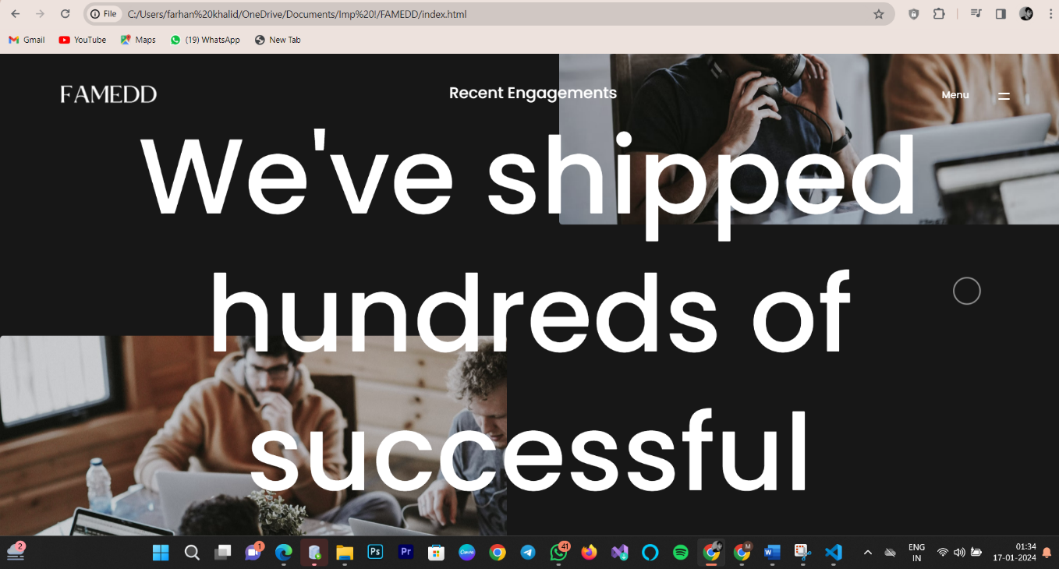

Figure 6: Picture to show some part of webpage after applying CSS

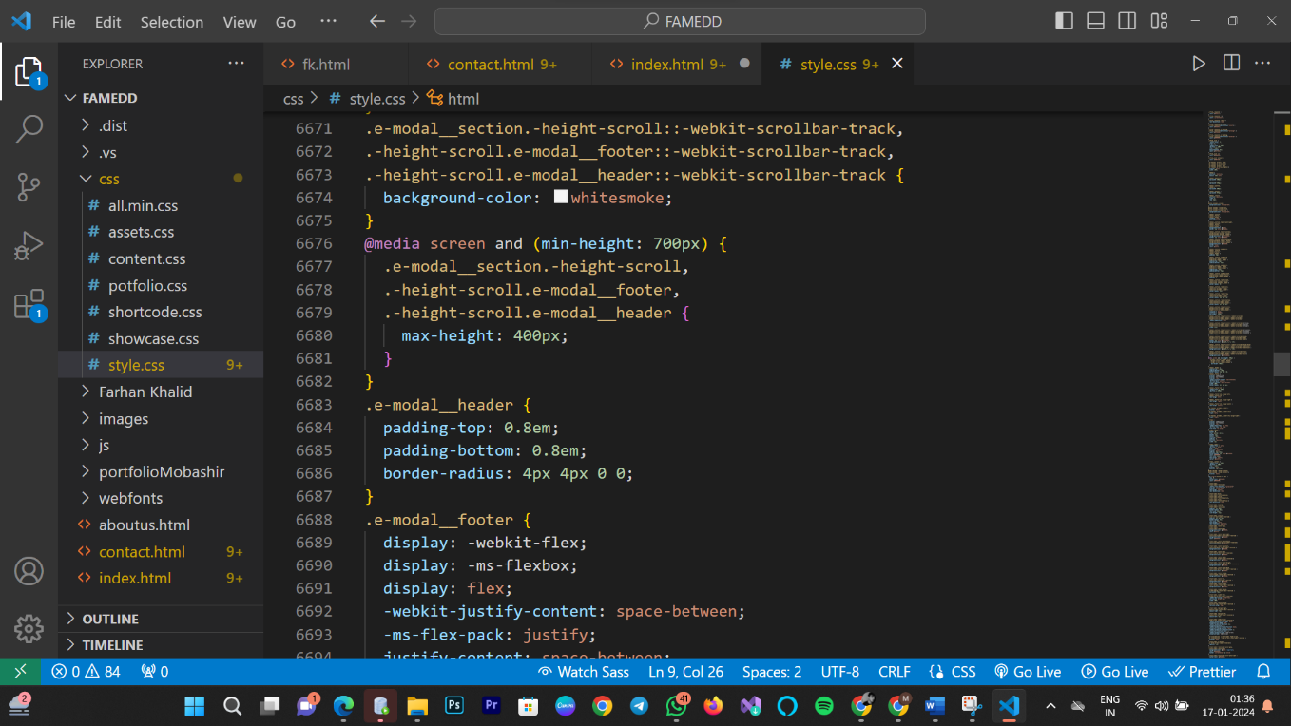

Figure 7: Picture to show some part of source code (CSS)

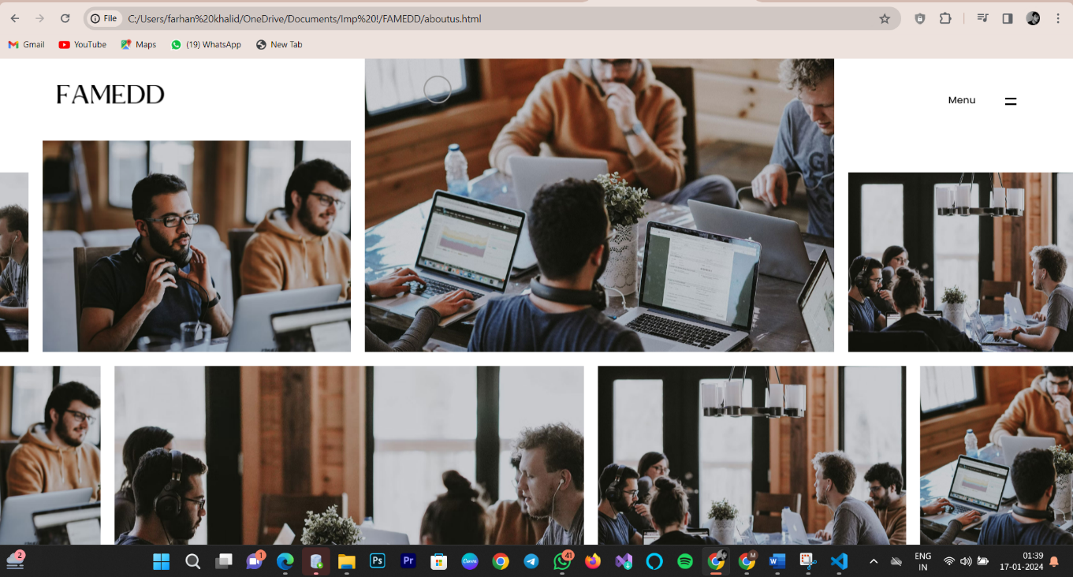

Figure 8: Picture to show some part of webpage after applying CSS.

JavaScript to imbue dynamic functionality into the webpage:
JavaScript's capability to manipulate the DOM dynamically enriches the user experience by allowing developers to create responsive and interactive elements. Dynamic content updates, such as live search suggestions or real-time chat features, are made possible through JavaScript's ability to fetch and display data asynchronously.Moreover, JavaScript supports the creation of interactive forms that dynamically adapt based on user input, guiding users through a personalized and engaging experience. This scripting language empowers developers to implement client-side validation, ensuring data integrity before submission, and providing users with immediate feedback.
In addition, JavaScript enables the implementation of event-driven functionalities, allowing developers to respond to user actions in real-time. This interactivity is evident in features like image sliders, carousels, and interactive maps, enhancing the visual appeal of the web page.
With the rise of Single Page Applications (SPAs), JavaScript frameworks such as Angular and React play a significant role in creating seamless, dynamic, and responsive web applications. These frameworks streamline the development process, enabling the construction of complex interactive features with greater efficiency.
In conclusion, JavaScript's versatility extends beyond simple interactivity, fostering the development of sophisticated and user-centric web applications.

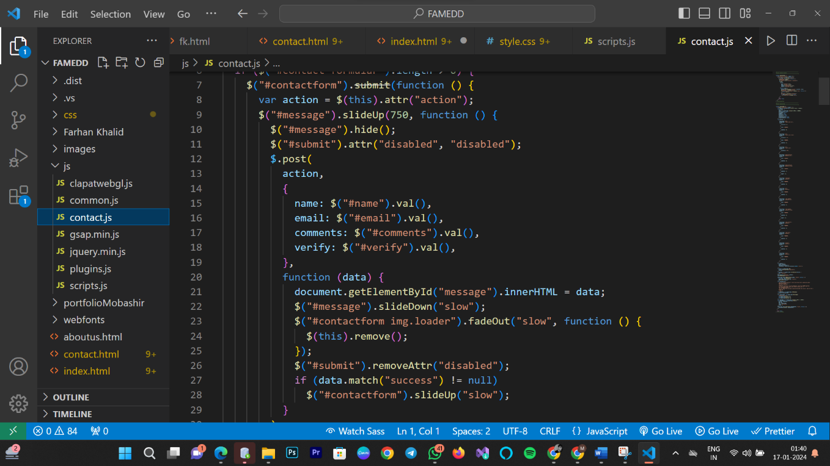

Figure 9: Picture to show some part of source code (JavaScript)

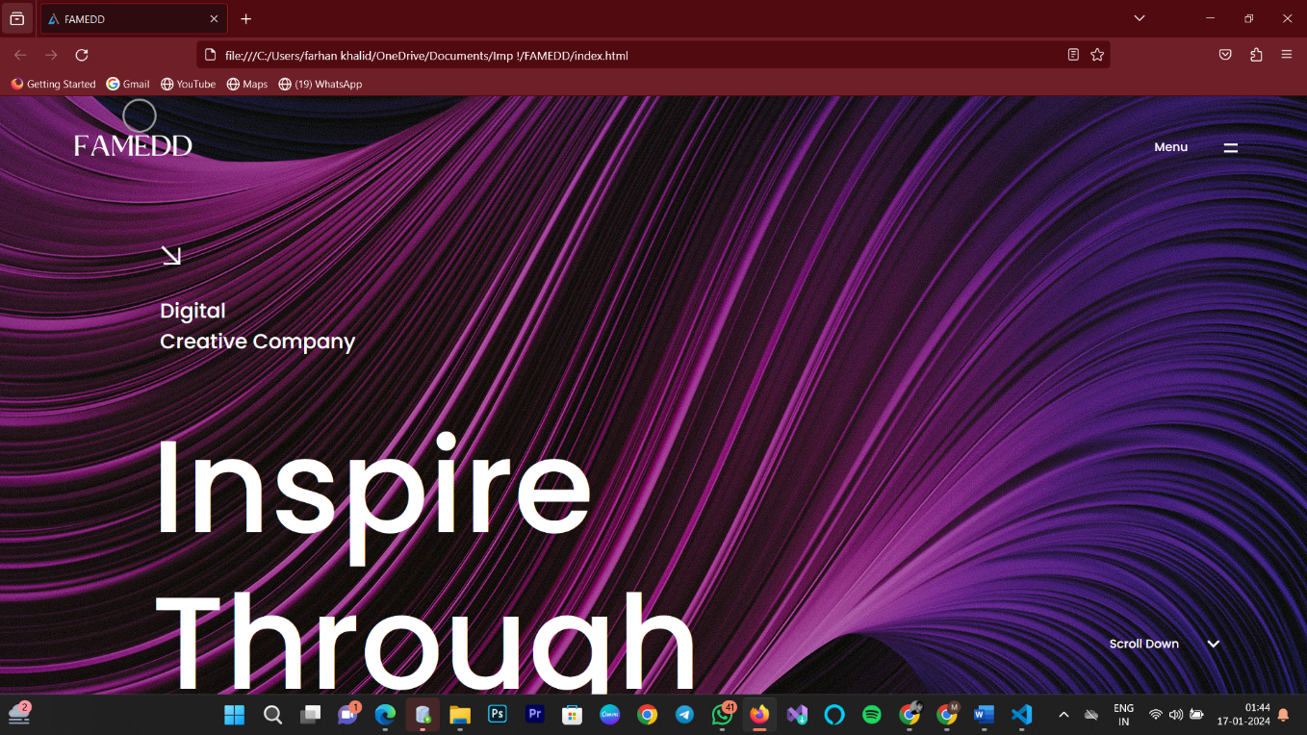

Figure 10

RESULT ANALYSIS

Performance Measures:
while we were creating the project and had created the UI we showed the UI to some people and we saw more people being interested in having their own website and were willing to give us money to make their website for them so, we thought while we are making websites for other why don't we make a website for ourselves which will help us in reaching out to more people and have our own business and with that thought FAMEDD was born.. Let's delve into the diverse array of interactive features that can transform a conventional tourist landing page into a vibrant and user- centric platform.
Here's Some Of the interactive Features of our web page:

Navigation Bar
Central to the interactive features of a tourist landing page, the navigation bar is a pivotal element guiding users through a seamless exploration experience. With categorized menus and responsive design, it facilitates easy access to destinations, accommodations, and activities. Incorporating drop-down options and a streamlined search function, the navigation bar ensures efficient and intuitive navigation. Its strategic placement and dynamic responsiveness provide users with a clear map of the site's offerings, enhancing engagement and satisfaction. In essence, the navigation bar is the interactive cornerstone, elevating the user's journey to discover and plan their travel experiences on the tourist landing page.
A navigation bar, often referred to as a navbar, is a user interface element commonly found on websites and applications. Its primary purpose is to help users navigate through different sections or pages of a website or application easily. The navigation bar typically appears at the top of a webpage or screen, though it can be located elsewhere depending on the design.

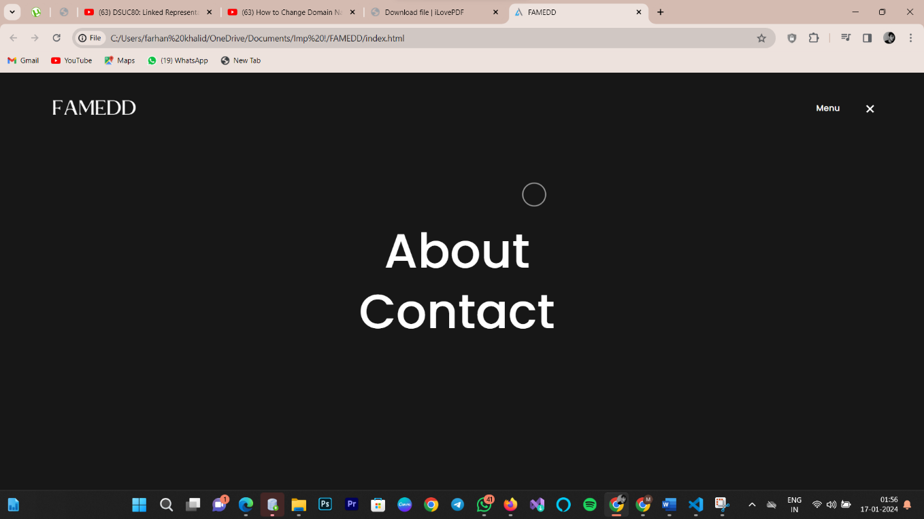

Figure 11: Navigation Bar

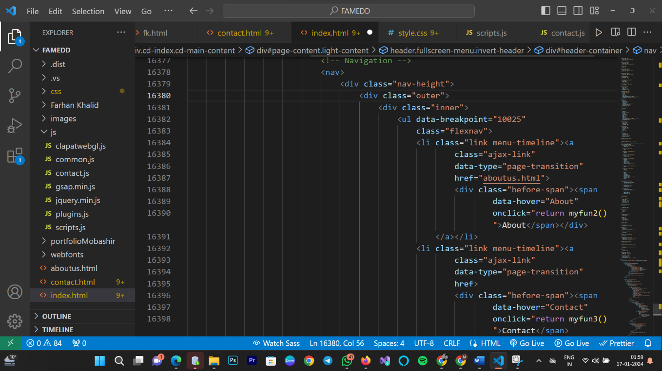

Figure 12: Source Code to Show how Bookmarks active in the Navigation Bar

About in the navigation bar to know the developers and our clients’ details:
The "About" page on a website typically contains information that introduces visitors to the purpose, values, history, and people behind the website or the organization it represents. While the specific content can vary depending on the nature of the website, industry, or organization, here are common elements found on an About page:
Mission or Purpose: A brief statement outlining the main goals and purpose of the website or organization. This helps visitors understand what the site is about and what it aims to achieve.
Company or Organization History: A timeline or narrative describing the history of the company or organization, including key milestones, achievements, and significant events.
Founding Team or Leadership: Information about the founders, key leaders, or the team behind the website or organization. This may include their backgrounds, roles, and contributions.
Vision and Values: An overview of the core values and vision that guide the website or organization. This helps convey the principles and beliefs that drive their work.
Company Culture: If applicable, details about the company culture, work environment, and any unique aspects that define the organization's identity.
Contact Information: Contact details, including email addresses, phone numbers, or a contact form, to make it easy for visitors to reach out with questions or inquiries.
Team Member Profiles: Brief bios or profiles of key team members, highlighting their roles, expertise, and contributions.
Company Culture: Information about the organization's culture, work environment, and any unique aspects that contribute to its identity.
Achievements and Milestones: Highlights of significant achievements, awards, or milestones reached by the organization. This can build credibility and showcase the organization's success.
Client Testimonials: If applicable, testimonials from clients or customers expressing satisfaction with the products or services provided by the organization.
Partnerships and Collaborations: Information about any strategic partnerships, collaborations, or affiliations that the organization has formed.
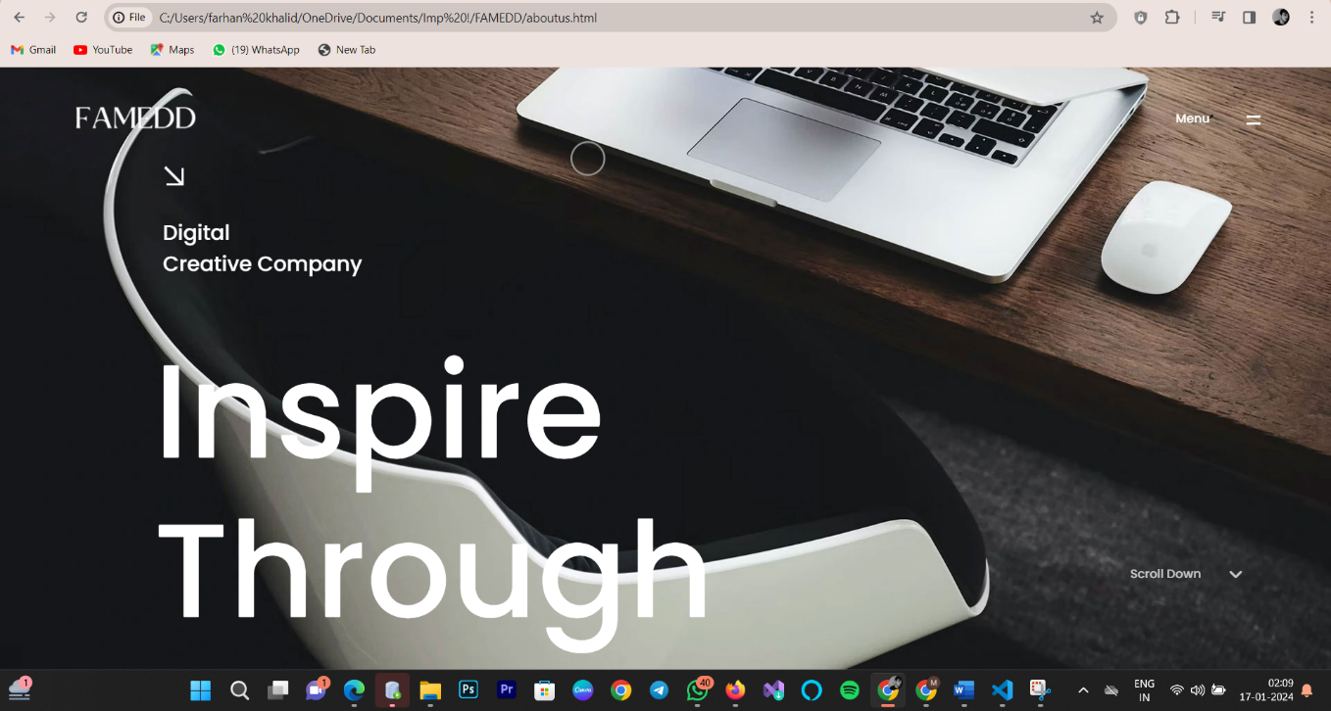

Figure 13: Picture to show About pages of the website.

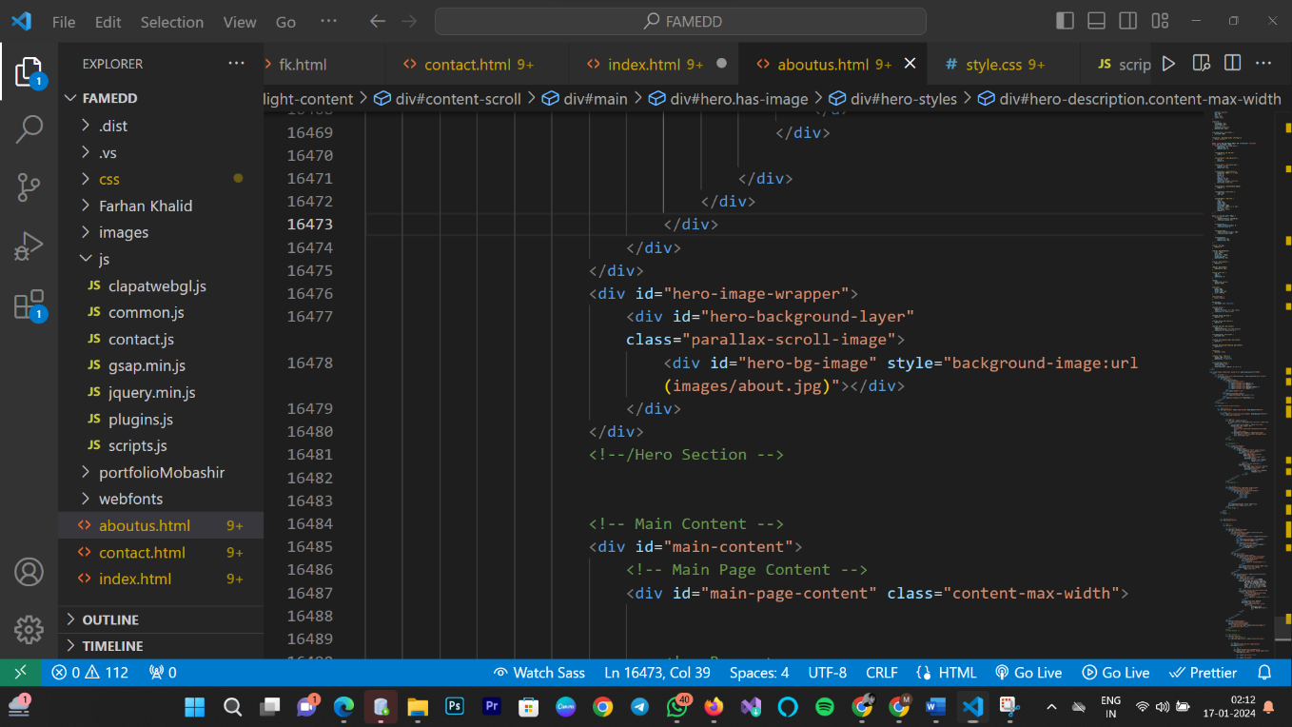

Figure 14: Source Code to Show how About Page is structured.

Our Portfolio
Creating a portfolio serves several objectives, depending on the context, such as whether it's a personal portfolio showcasing your work or a professional portfolio for a business. Here are some common objectives for making a portfolio:
Showcasing Work: The primary goal of a portfolio is to showcase your work or the work of a business. This could include projects, designs, artworks, case studies, or any other relevant examples of what you or your team can accomplish.
Demonstrating Skills and Expertise: A portfolio provides a platform to highlight your skills, talents, and expertise in a specific field. It's a way to demonstrate what you're capable of and what sets you apart.
Building Credibility: A well-curated portfolio adds credibility and professionalism. It acts as evidence of your capabilities and can be a persuasive tool when seeking job opportunities, clients, or partnerships.

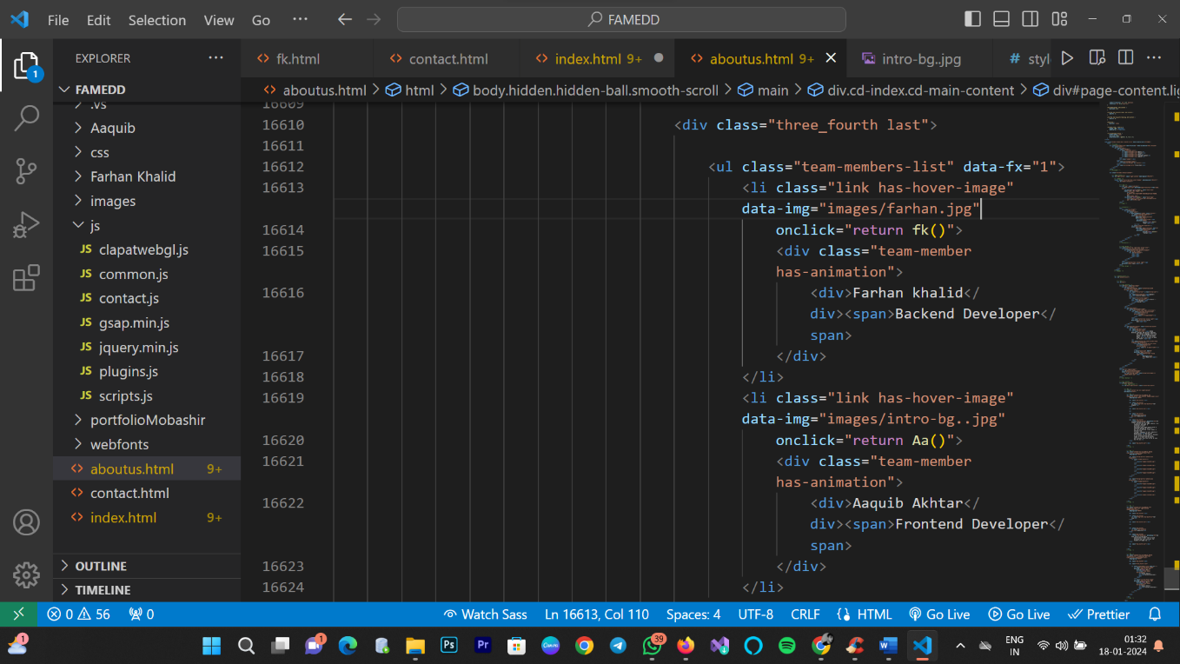

Figure 15: Picture to show Portfolio code of the website.

Service
The term "information service section" is not specific enough to determine its exact meaning, as it can vary depending on the context and the organization to which it refers. Different industries and organizations may use this term to describe different functions. Here are a few possibilities:
Library or Information Center: In some organizations, especially educational institutions or large companies, an information service section may refer to a library or information center. This section is responsible for managing and providing access to various information resources, including books, journals, databases, and other materials.
Customer Service: In a business or customer-oriented context, an information service section might be a part of customer service. This section could be responsible for handling inquiries, providing information about products or services, and assisting customers with their needs. information service section that deals with the dissemination of public information, managing records, and providing citizens with access to government-related information

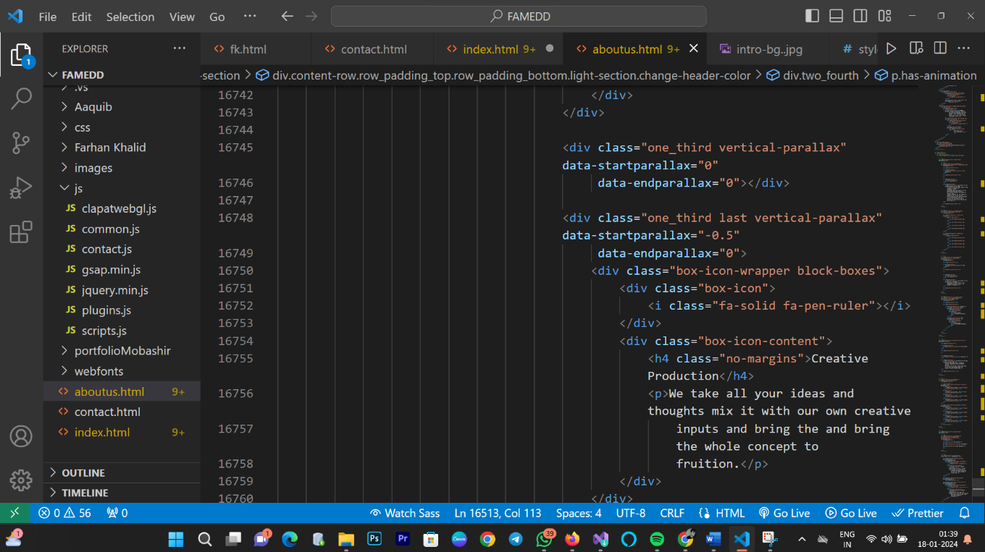

Figure 16: Picture to show Service Section code of Website.

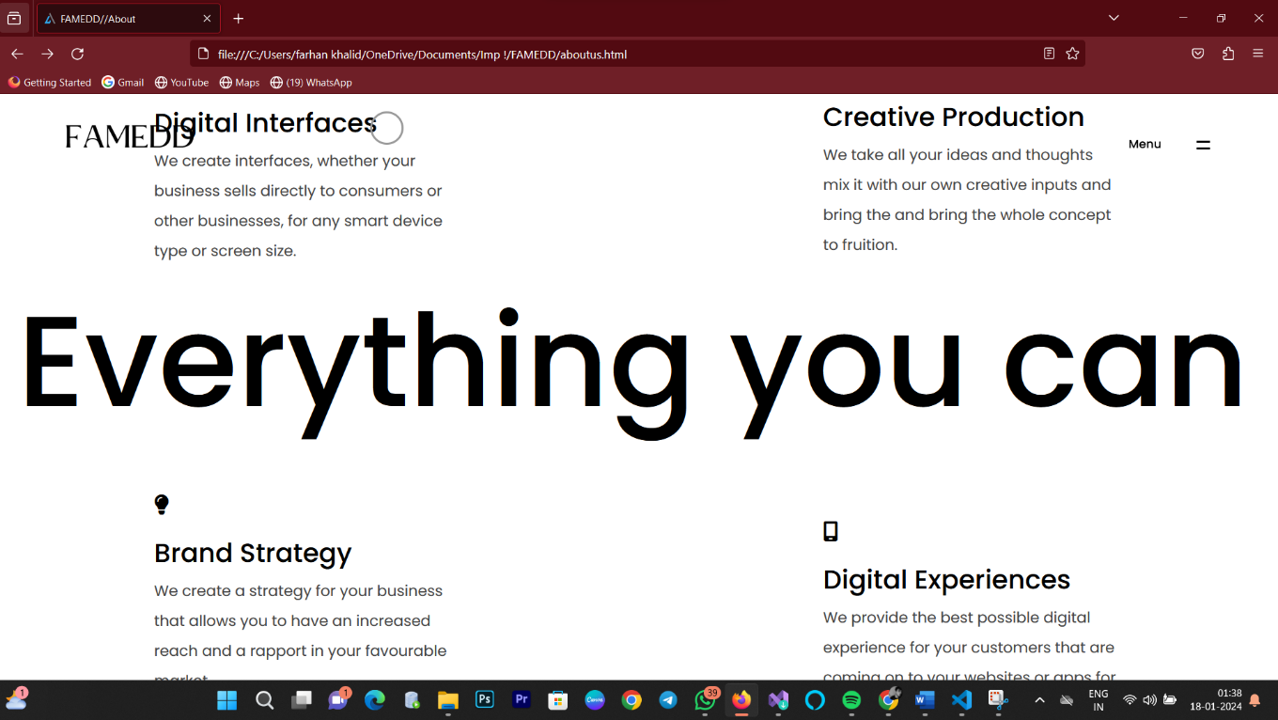

Figure 17: Picture to show Service Section of Website.



Figure No. 18

Blog

A blog section typically holds a collection of articles, posts, or entries that are organized chronologically, with the most recent content appearing at the top. The content in a blog can cover a wide range of topics, depending on the theme or focus of the blog. Here are some common types of information that a blog section might hold:
Informative Articles: Blogs often feature articles that provide information on specific topics. This could include how-to guides, tutorials, explanations of concepts, or educational content.
News and Updates: Some blogs serve as a platform for sharing news and updates related to a particular industry, niche, or subject matter. This helps keep readers informed about the latest developments. Bloggers may share their opinions, thoughts, and commentary on various subjects. This can provide a platform for discussion and exchange of ideas.
This adds a personal touch and can help readers relate to the content.

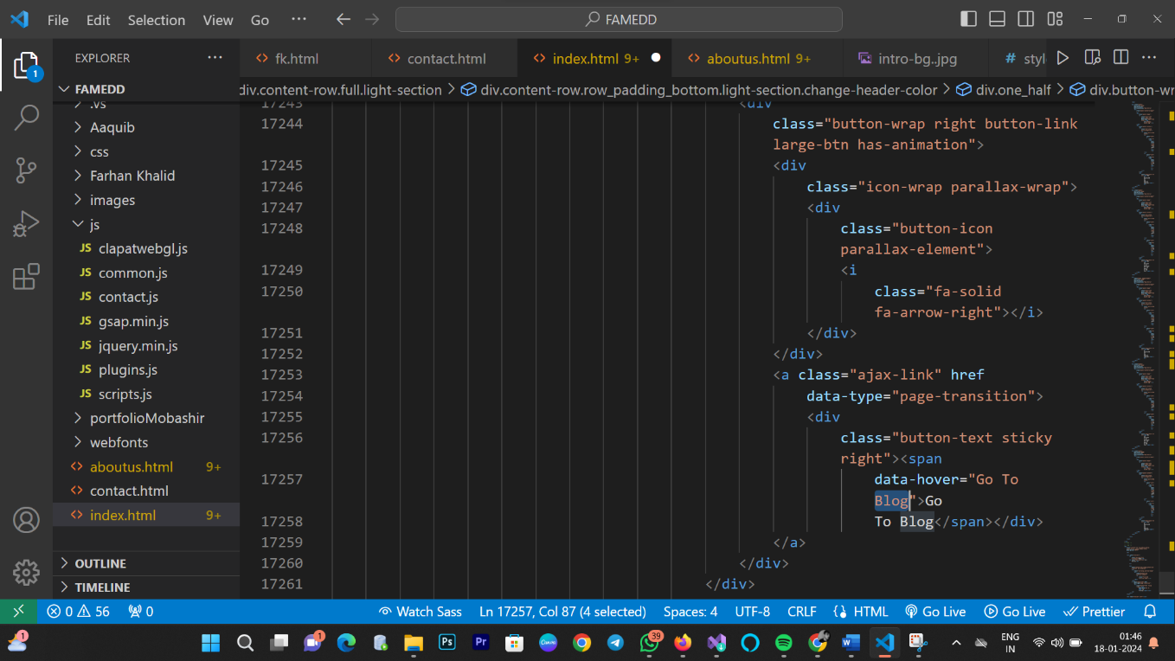

Figure 19: Picture to show Service Section code of Website.

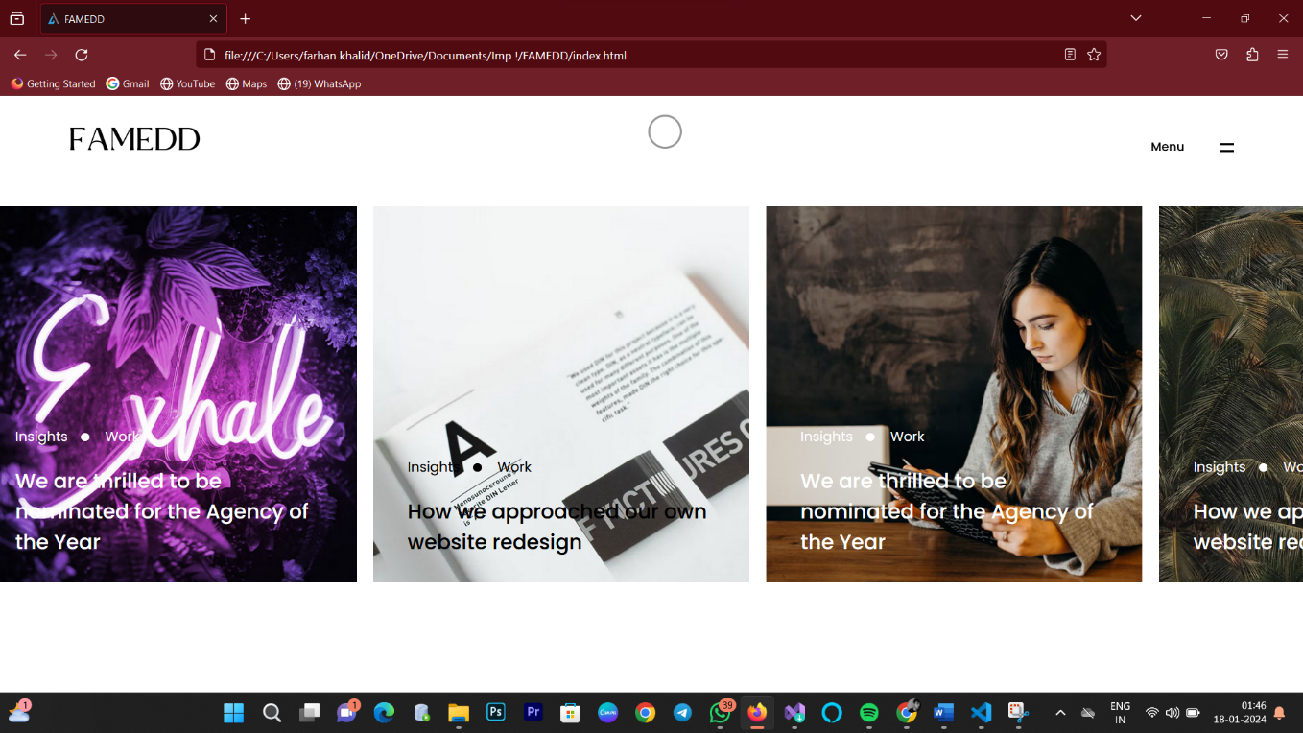

Figure 20: Picture to show Blog section of the web page.

Contact
Enhance A "Contact" section on a website typically contains information that allows visitors to get in touch with the owner or administrators of the site. This section is crucial for facilitating communication between the website and its users. The specific information included in a Contact section may vary, but it commonly includes:
Contact Form: A web form that users can fill out to send messages directly through the website. This form usually asks for the user's name, email address, subject, and message. It provides a convenient way for users to communicate without having to use their email client.
Email Address: Displaying an email address (or multiple email addresses) is a common practice. Users can use their own email client to send messages directly.
Phone Number: Some websites include a phone number to provide an additional means of contact. This is particularly important for businesses that want to offer phone support.

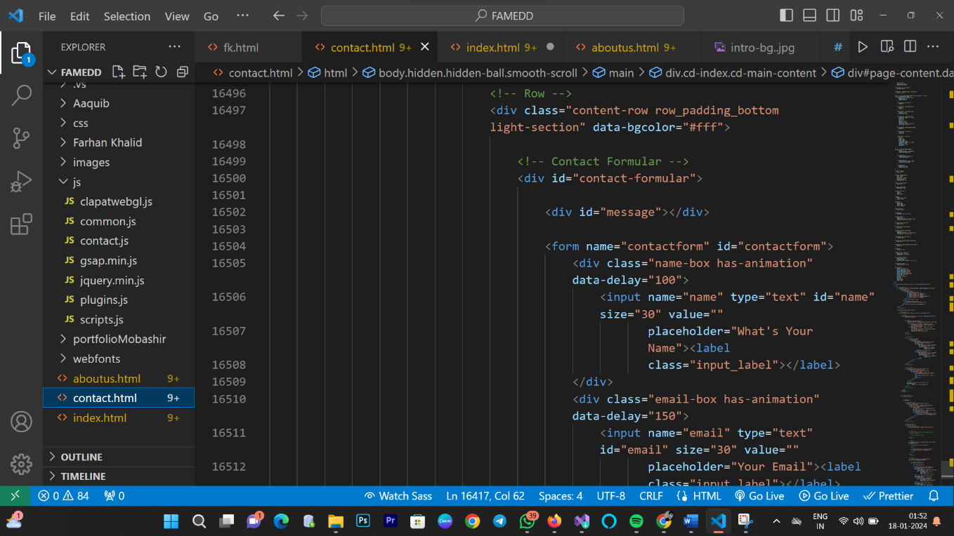

Figure 21: Source Code for Contact section of the web page.

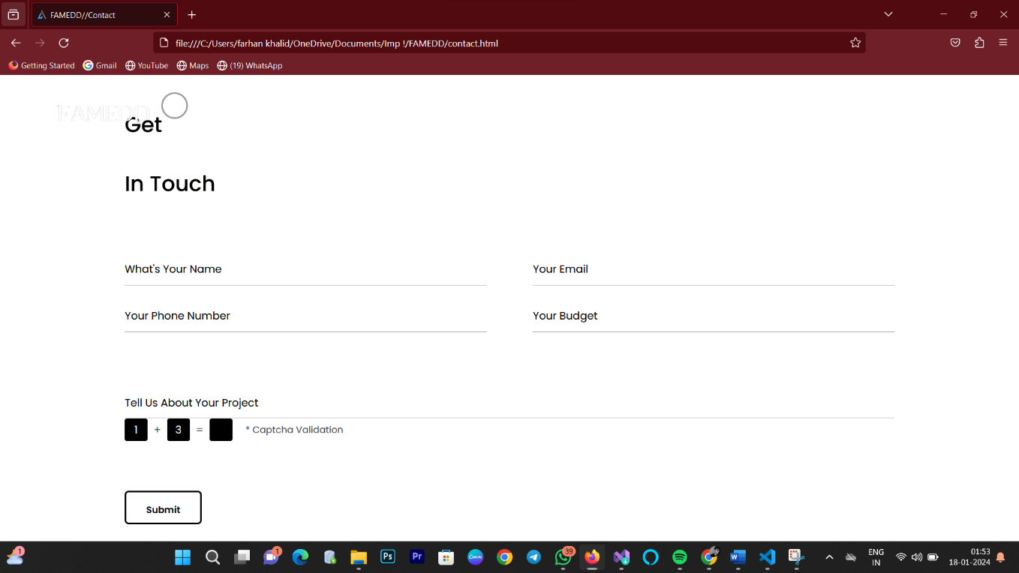

Figure 22: Picture to show Contact section of the web page.

Footer Section
The footer section of a website typically contains various types of information that are important but are not necessarily the primary focus of the site's main content. The content in the footer may vary depending on the type of website and its purpose, but common elements found in footers include:
Contact Information: Similar to the Contact section, the footer often includes contact details such as an email address, phone number, or a link to the Contact page.
Navigation Links: Some websites include a condensed version of their main navigation menu in the footer. This provides users with easy access to important pages, even when they scroll to the bottom of a page.
Copyright Information: The footer commonly includes the copyright notice for the website, indicating the ownership of the content and the year of publication.
Privacy Policy and Terms of Service Links: For legal and compliance reasons, websites often link to their privacy policy and terms of service in the footer. These documents outline how user data is handled and the terms under which users interact with the site.

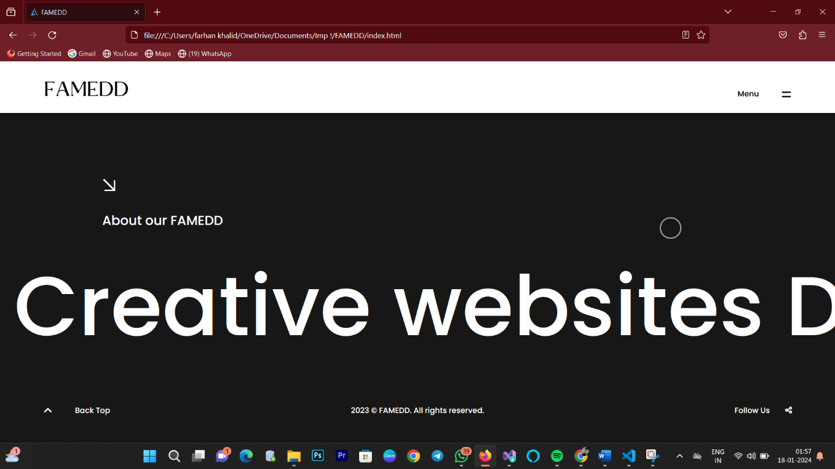

Figure 23: Picture to show Footer section of the web page.

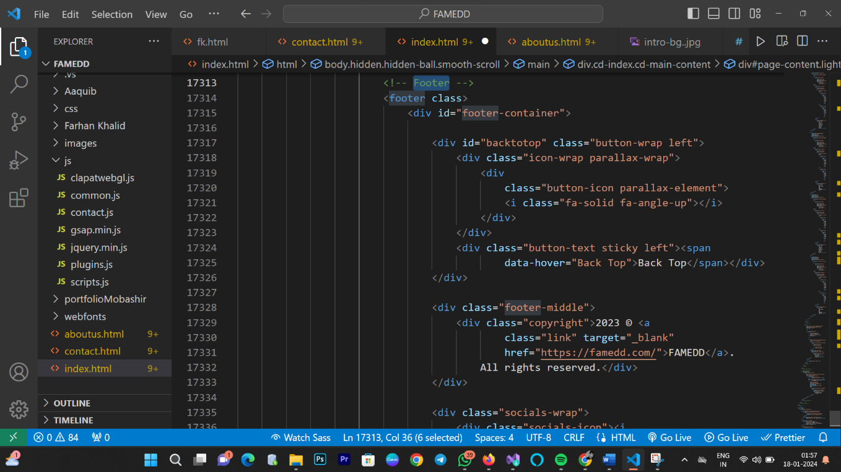

Figure 24: Source Code for Footer section of the web page.

The primary aim of Famedd is to streamline and enhance the dining experience by leveraging digital technology. Here are some key objectives or aims that are often associated with companies like Famedd in the food tech industry:
Digital Ordering:
Famedd aims to facilitate digital ordering for customers. This involves creating a seamless and user-friendly platform or app that allows users to browse menus, place orders, and make payments using their smartphones or other digital devices.
Contactless Payments:
In the context of evolving health and safety concerns, especially during the COVID-19 pandemic, Famedd and similar platforms aim to promote contactless payment options. This reduces the need for physical contact between customers and restaurant staff during the ordering and payment processes.
Enhanced Customer Experience:
Famedd aims to improve the overall customer experience by providing a convenient and efficient way for customers to interact with food establishments.
This may involve features such as personalized recommendations, loyalty programs, and order tracking.
Integration with Restaurants:
Famedd likely works to integrate its technology with the operations of restaurants and food businesses. This could involve integrating point-of-sale (POS) systems, kitchen management systems, and other tools to ensure a smooth and efficient workflow for both customers and restaurant staff.
Support for Small Businesses:
Famedd may focus on providing solutions that are accessible to a wide range of food establishments, including small and local businesses. This could contribute to the growth and sustainability of smaller players in the food industry.
Data Analytics and Insights:
The platform may offer analytics and insights to restaurants, helping them understand customer behavior, popular menu items, and other relevant data.
Digital Menu:
Users can browse through a digital representation of the restaurant's menu, complete with descriptions, images, and prices.
Ordering System:
Famedd likely provides an online ordering system that allows customers to place orders directly through a website or a mobile app.
Contactless Ordering:
To enhance safety and convenience, Famedd may offer contactless ordering options, allowing customers to order without physical menus or contact with staff.
Customization:
Customers may have the option to customize their orders, selecting preferences or making special requests directly through the platform.

Future Enhancements & Scope

Integration with Emerging Technologies:
Famedd may explore integrating emerging technologies like artificial intelligence (AI) and machine learning (ML) to enhance user experiences. This could involve personalized recommendations, predictive ordering suggestions, and improved data analytics.

Enhanced User Interfaces:
Future enhancements might include improvements to the user interface (UI) and user experience (UX) design, making the platform more intuitive and user-friendly for both customers and restaurant staff.

Augmented Reality (AR) Features:
Integration of AR features in the ordering process or menu exploration could be a potential avenue for enhancing engagement and providing a more interactive experience.

Expansion of Services:
Famedd might expand its services to cover a broader range of functionalities, such as loyalty programs, promotions, and marketing tools to help restaurants attract and retain customers.

Global Expansion:
If Famedd operates regionally or nationally, it might explore opportunities for global expansion, reaching new markets and partnering with international restaurants.

Blockchain for Security:
Implementing blockchain technology for secure and transparent transactions could be a future consideration, ensuring the integrity of payment processes and customer data.

Sustainability Initiatives:
The platform might incorporate features that support sustainability, such as options for reducing food waste, promoting eco-friendly practices, or partnering with environmentally conscious establishments.

Enhanced Data Security:
Given the sensitivity of customer data and financial transactions, Famedd may invest in robust cybersecurity measures and privacy features to ensure the security of user information.

CONCLUSION
Build more than a website from selling online, starting a blog, and organizing events to promoting your business and building your community, create a website that can grow with you. So, in conclusion our project’s purpose is to take your business where it needs to go with the creation of famed is to dwell in the vast space or market available in web development and with that help people who are struggling to compete or stay in the market after the huge surge in digitization of the whole world where if people even want to get the smallest things such as there day to day groceries or even their everyday clothing they are ordering it online.
So basically, with the help of famed, we will be providing people with a platform with the help which they will be able to take their businesses online and have their websites with the features they feel are best for their websites at a price they will be able to afford and finally will be able widen their businesses and can get in touch with new customers. We are already working with a small business of rental cars called faulty who have trusted us to provide them with a website through which people can buy or rent their cars or sell them cars and we also are working with a food restaurant called zaika whom we are helping to get a website with which people can directly order food without involvement of any third party and do payments. These are some of the projects with which we hope to build a portfolio and can gain trust of the future customers we get with the quality of work we are doing.

Bibliography

To learn about the market that we are going to be working in we have studied and conducted our research with the help of following websites: -
https://www.webfx.com/
https://www.marketresearch.com/
blog.hubspot.com

